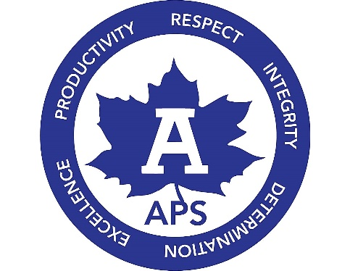
The Adrian Schools Educational Foundation has graciously awarded a grant to Springbrook Middle School staff to incorporate a parental component into our Positive Behavioral Intervention and Support initiative. We hope that with the help of parents, together we can provide what students need to achieve social, emotional, and academic success. With this grant, we have purchased several Love and Logic® books and audio CD's which are available for parents to check-out of our lending library. We also were able to purchase materials necessary to offer Love and Logic® classes to parents free of charge.

What IS Parenting with Love and Logic?
"The Love and Logic approach to parenting is built around the science of crafting caring and respectful relationships. An authentic, loving connection between parents and their children is the root of a healthy, thriving relationship built on trust and understanding.
Sounds easy enough but never before in history have parents been faced with so many challenges! Our approach provides a variety of simple and effective strategies for parenting children from birth to adulthood. Whether you’re embarking for the first time with your new baby or navigating the turbulent teens with your youngest, our strategies and techniques will help you create calm and loving solutions.
Choose "Love"
The “Love” in Love and Logic means that we love our kids so much that we are willing to set and enforce limits. This “Love” also means that we do so with sincere compassion and empathy.
Choose "Logic"
The “Logic” in Love and Logic happens when we allow children to make decisions, affordable mistakes and experience the natural or logical consequences. When we balance this with sincere empathy, they develop the following logic: The quality of my life depends on the quality of my choices.
​
With the loving yet powerful tools of Love and Logic, we can help our children learn to make good choices and experience happy lives while maintaining their love and respect."

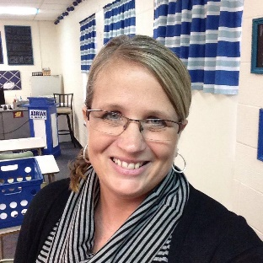
Hello! I’d like to introduce myself as your Parenting with Love and Logic independent facilitator. I currently teach the AMPS program at Springbrook Middle School. I have taught alternative education for over 25 years, and have also taught parenting courses in a variety of settings. As an educator, I firmly believe in this program and as a mother of four, I have directly seen and benefited from its positive results. Because of this, I am thrilled to be able to offer these sessions here at Adrian Public Schools. I hope to see you there! -- Jodi Ford

